Week-1

Learning Module:

* **Html:** Learning about the new tags and functionalities added in HTML 5.
* **CSS:** Understanding the core techniques of applying styling for responsive web application.
* **JavaScript:** Core programming, Promises, async-await, service workers.
* **Bootstrap** UI**:** Hands-on the components to setup the responsive web application.
* **ReactJS:** Introduction to ReactJS.

Assignment : Create two webpages using Bootstrap 4 UI, on 1st page take details from user to sign-up and on 2nd page is login page, after successfully login take the user to the 3rd webpage where show them their data taken while sign-up.

* Total Pages : 3
* Store data using session-storage functionality of browser
* Use all major HTML input form fields checkbox, radio-button etc. while sign-up.
* Validate all input fields of input boxes using JavaScript.

File Structure:

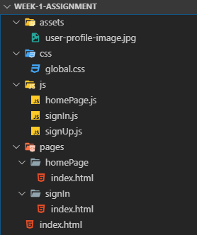

* Here I have define separate directories for all same types like ‘js’ directory for all JavaScript files, ‘css’ directory for all css files.
* Here I have created one external css file global.css file which is common for all pages.
* Also created separate JavaScript files for all html pages.

HTML Files:

Bootstrap:

CSS

Copy-paste the stylesheet <link> into your <head> before all other stylesheets to load our CSS.

<link rel="stylesheet" href="https://maxcdn.bootstrapcdn.com/bootstrap/4.0.0/css/bootstrap.min.css" integrity="sha384-Gn5384xqQ1aoWXA+058RXPxPg6fy4IWvTNh0E263XmFcJlSAwiGgFAW/dAiS6JXm" crossorigin="anonymous">

JS

Many of our components require the use of JavaScript to function. Specifically, they require [jQuery](https://jquery.com/), [Popper.js](https://popper.js.org/), and our own JavaScript plugins. Place the following <script>s near the end of your pages, right before the closing </body> tag, to enable them. jQuery must come first, then Popper.js, and then our JavaScript plugins.

We use [jQuery’s slim build](https://blog.jquery.com/2016/06/09/jquery-3-0-final-released/), but the full version is also supported.

<script src="https://code.jquery.com/jquery-3.2.1.slim.min.js" integrity="sha384-KJ3o2DKtIkvYIK3UENzmM7KCkRr/rE9/Qpg6aAZGJwFDMVNA/GpGFF93hXpG5KkN" crossorigin="anonymous"></script>

<script src="https://cdnjs.cloudflare.com/ajax/libs/popper.js/1.12.9/umd/popper.min.js" integrity="sha384-ApNbgh9B+Y1QKtv3Rn7W3mgPxhU9K/ScQsAP7hUibX39j7fakFPskvXusvfa0b4Q" crossorigin="anonymous"></script>

<script src="https://maxcdn.bootstrapcdn.com/bootstrap/4.0.0/js/bootstrap.min.js" integrity="sha384-JZR6Spejh4U02d8jOt6vLEHfe/JQGiRRSQQxSfFWpi1MquVdAyjUar5+76PVCmYl" crossorigin="anonymous"></script>

This file contain signUp form,

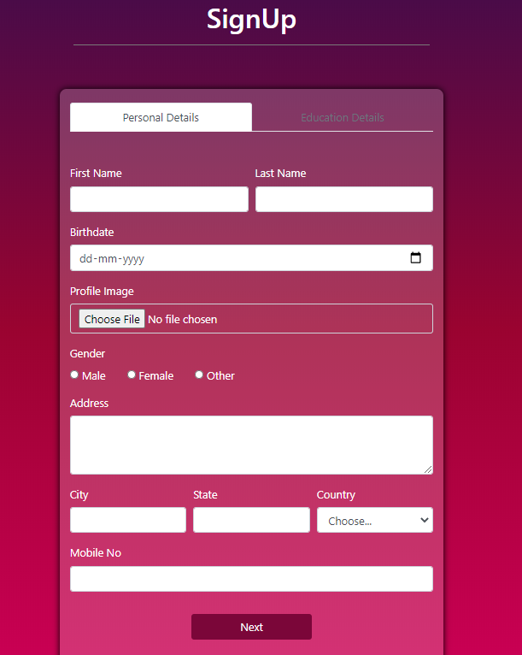

Code:

<div class="col-4 text-center mx-auto">

<h1 class="text-white" style="margin-top: 20px;">SignUp</h1>

<hr>

</div>

* Show the heading of the page
* Col-4 is bootstrap class which means it takes 4 column from 12 column of page
* mx-auto gives equal margin from left and right side
* text-white makes text colour white
* I have also use the inline style for give margin 20px from top

<div class="nav-justified my-5 form-container col-11 col-sm-8 col-md-6 col-lg-4">

<ul class="nav nav-tabs" id="myTab" role="tablist">

<li class="nav-item">

<a class="nav-link active" id="personal-details-tab" data-toggle="tab" href="#personal-details" role="tab" aria-controls="personal-details" aria-selected="true">Personal Details</a>

</li>

<li class="nav-item">

<a class="nav-link disabled" id="education-details-tab" data-toggle="tab" href="#education-details" role="tab" aria-controls="education-details" aria-selected="false" disabled>Education Details</a>

</li>

</ul>

</div>

* Create two tab personal details and education details which shows form for selected nav. Default personal detail form will show.
* First Personal detail form will verified and then after education detail tab will be active.
* And after fill educational detail form will data will be saved to the session storage.

<form action="./pages/signIn/index.html" method="POST" class="my-5" id="signUp-form" onsubmit="return saveData()">

<!-- nav body -->

<div class="tab-content" id="myTabContent">

<!-- Personal Details -->

<div class="tab-pane fade show active mx-auto" id="personal-details" role="tabpanel" aria-labelledby="personal-details-tab">

<div class="form-row">

<!-- first Name -->

<div class="form-group col-md-6">

<label for="firstName">First Name</label>

<input type="text" class="form-control" id="firstName" name="firstName">

</div>

* I have created form using html form tag which call js method saveData() for validation and save data to session storage. If method return true than user redirect to signIn page and if return false than user stay In same page.
* For input I have used form-row class of bootstrap. In that I have use form-group class for group <label> and <input> tags. In input tag I have used form-control bootstrap class. Which gave better style for input text box.
* So same type of process for all input text box.

Validate user Data in Js files:

* Get value from form by giving id as parameter in do

var firstName = document.getElementById('firstName').value;

* Then apply validation on each field using regex and if input is not valid then show error message to user

function checkfirstName(firstName) {

var regexFirstName = /^[a-zA-z]+$/;

if (!regexFirstName.test(firstName)) {

alert("Enter valid firstName.");

return false;

}

return true;

}

* After successfully validation, Store user data into session storage

sessionStorage.setItem(key, value);

SignIn:

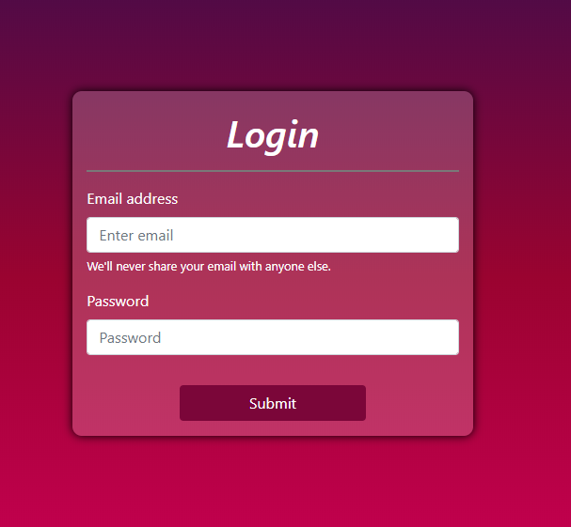

* This is login form where user can login by using email and password.
* If the email or password is incorrect then shown an error message to user and if its valid then user will redirect to homepage
* If user try to access login or homepage with out registration then user will redirect to the signUp page.

if (sessionStorage.getItem("userEmail") == null || sessionStorage.getItem("userEmail") == "") {

window.location.replace('../../index.html');

}

HomePage:

* After successful login user can see his/her all details enter during registration.
* After logout all data from session storage will removed and user redirect to the signUp page.

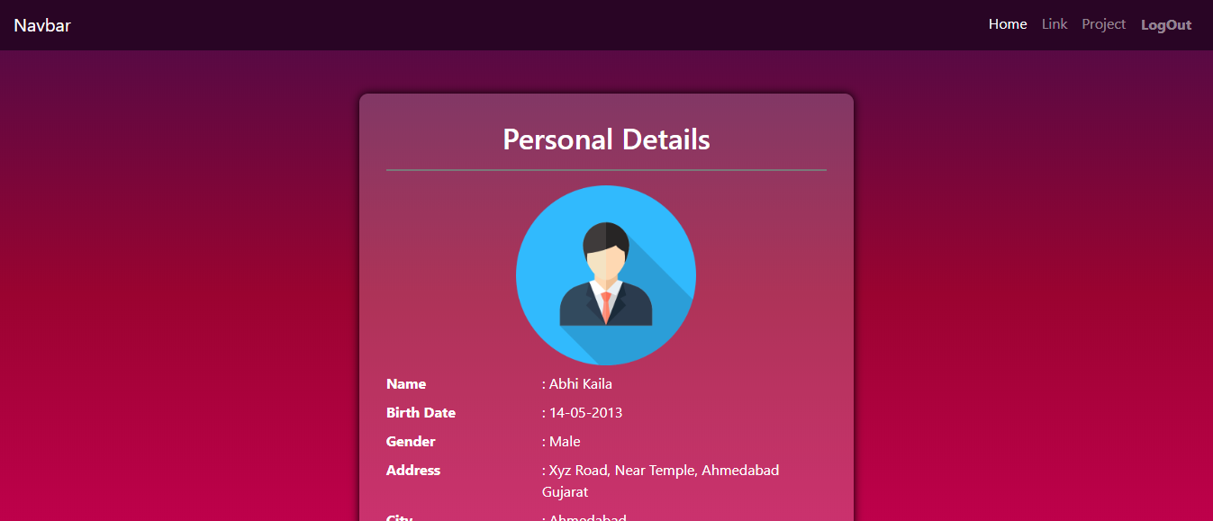

* For get values from session storage

// getValues from session storage

getValuesFromSessionStorage(userData);

* For logout simply clear the user data from the session storage and redirect user to the registration page.

// clear the session storage data

sessionStorage.clear();

Learning Outcome:

In this week I have learn about html, css, JavaScript, bootstrap and react. How we can store data into session storage, how to retrieve data. Use various bootstrap classes, form validation, etc.